WEB TECHNOLOGY COCSC04- LAB FILE

Netaji subhas university of technology |DWARKA,NEW DELHI

By-amogh garg

Roll Number: 2020uco1688

2021

**INDEX**

1. LAB-1: Try Basic HTML Tags, Table Tags, List Tags, Image Tags, Forms -Page:1

2. LAB-2: Implement forms using HTML, FRAMES, CSS. -Page:2-5

3. LAB-3: Write a JavaScript code which shows the current date and time. -Page:6-7  
Change the colour of the paragraph element using JavaScript and count   
the number and names of dropdown menu and show them as pop-up in   
the window.

4. LAB-4: Write a JavaScript to design a simple calculator to perform the -Page:8-10  
following operations: sum, product, difference and quotient.

5. LAB-5: Write a JavaScript that calculates the squares and cubes of the -Page:11  
numbers from 0 to 10 and outputs HTML text that displays the resulting   
values in an HTML table format.

6. LAB-6: Write a JavaScript code that displays text “TEXT-GROWING” with -Page:12  
 increasing font size in the interval of 100ms in RED COLOR, when the font   
size reaches 50pt it displays “TEXT-SHRINKING” in BLUE colour. Then the   
font size decreases to 5pt.

7. LAB-7: Develop and demonstrate a HTML5 file that includes JavaScript -Page:13-14  
script that uses functions for the following problems: a. Parameter: A string   
Output: The position in the string of the left-most vowel  
b. Parameter: A number  
Output: The number with its digits in the reverse order

8. LAB-8: Write an HTML page with JavaScript that takes a number from one -Page:15-16  
text field in the range 0-999 and display it in other text field in words. If the   
number is out of range, it should show “out of range” and if it is not a number,   
it should show “not a number” message in the result box.

9. LAB-9: Connection of Database with PHP -Page:17

10. LAB-10: HTML forms with PHP -Page:18-19

**LAB-1**

## Question: Try Basic HTML Tags, Table Tags, List Tags, Image Tags, Forms.

**CODE: 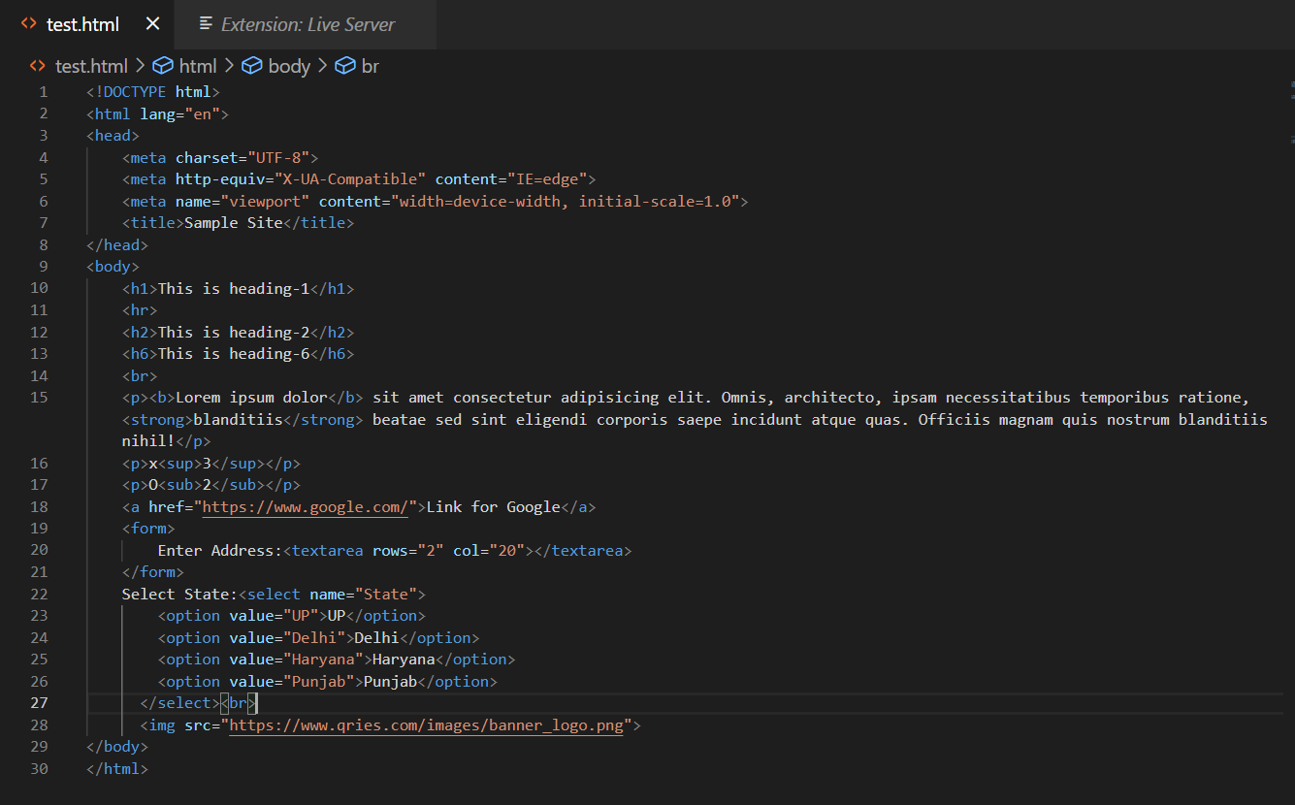 OUTPUT:** 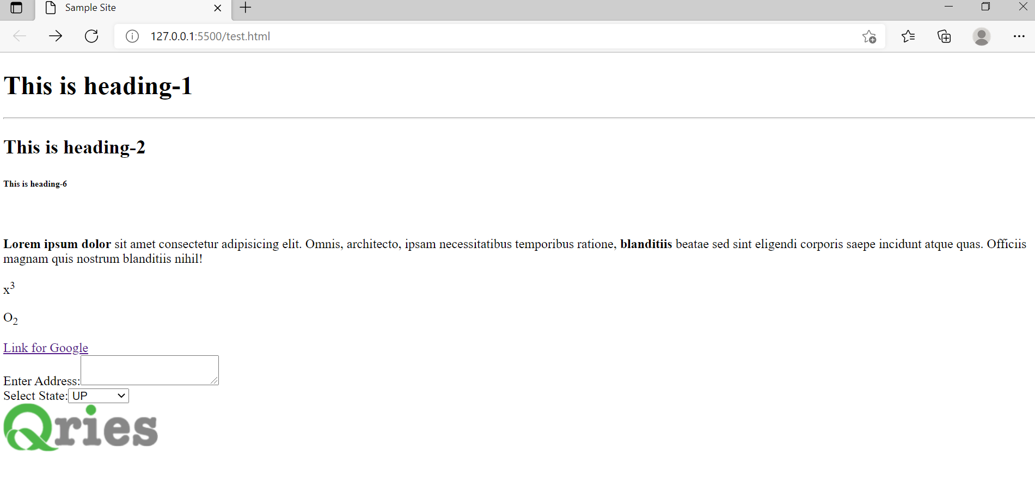

**LAB-2**

## Question: Implement forms using HTML, FRAMES, CSS.

**CODE: 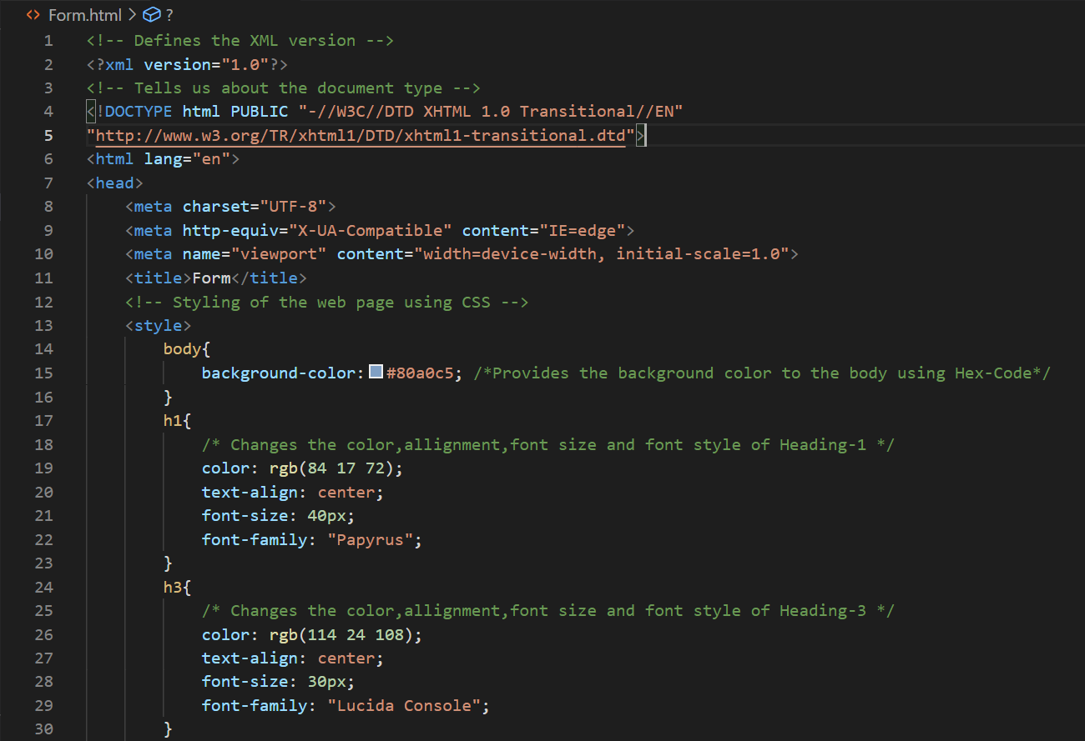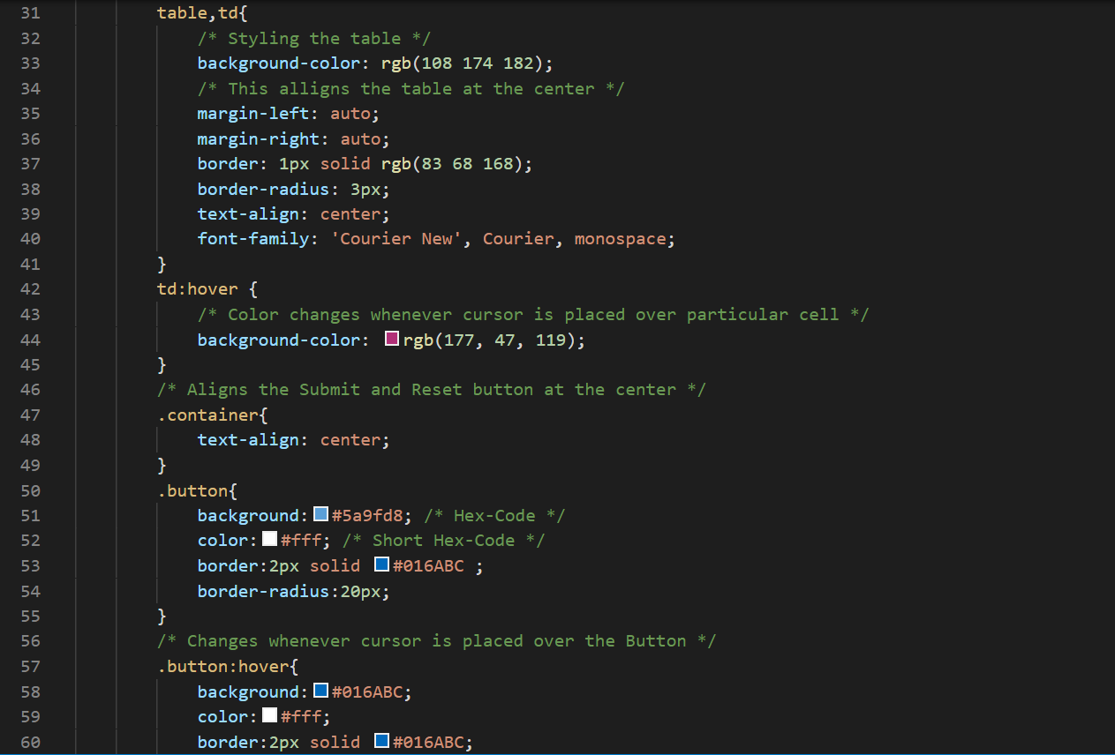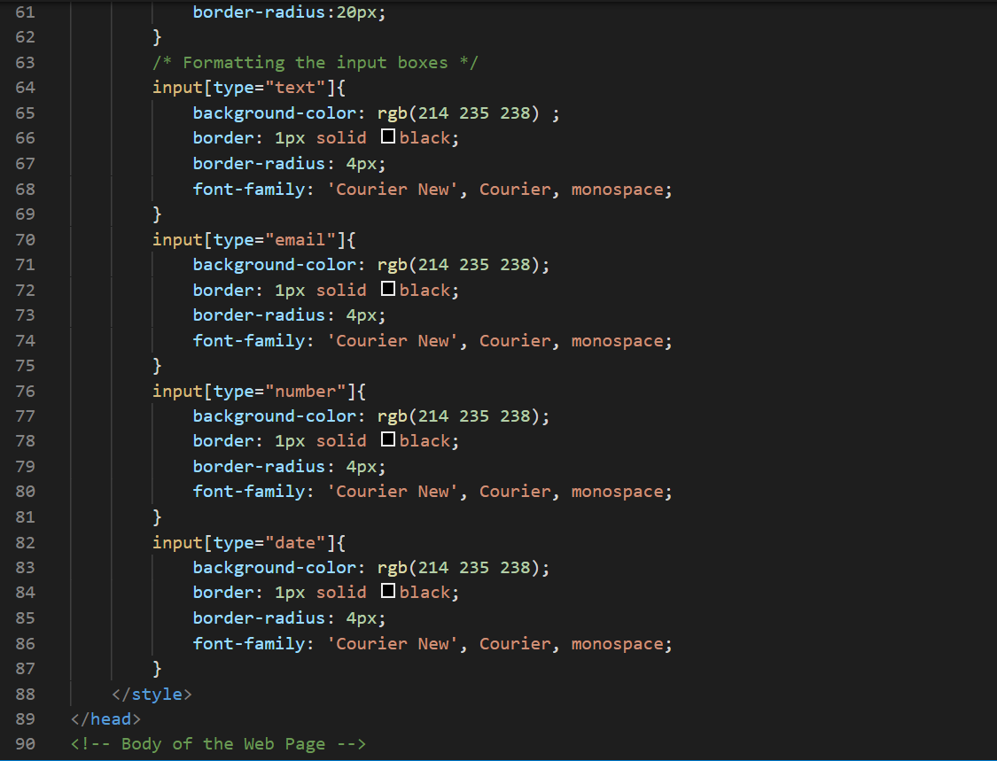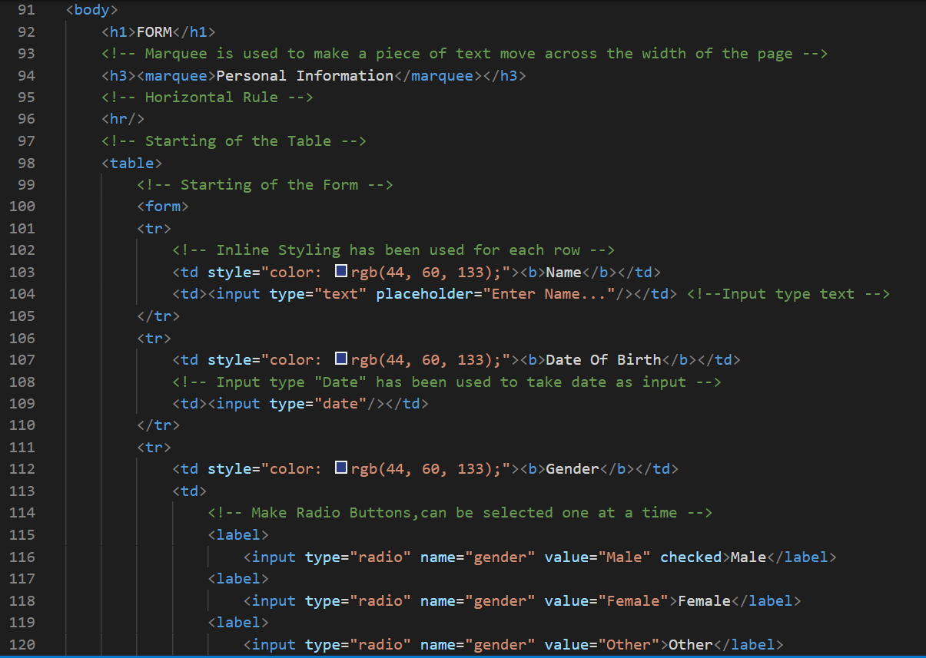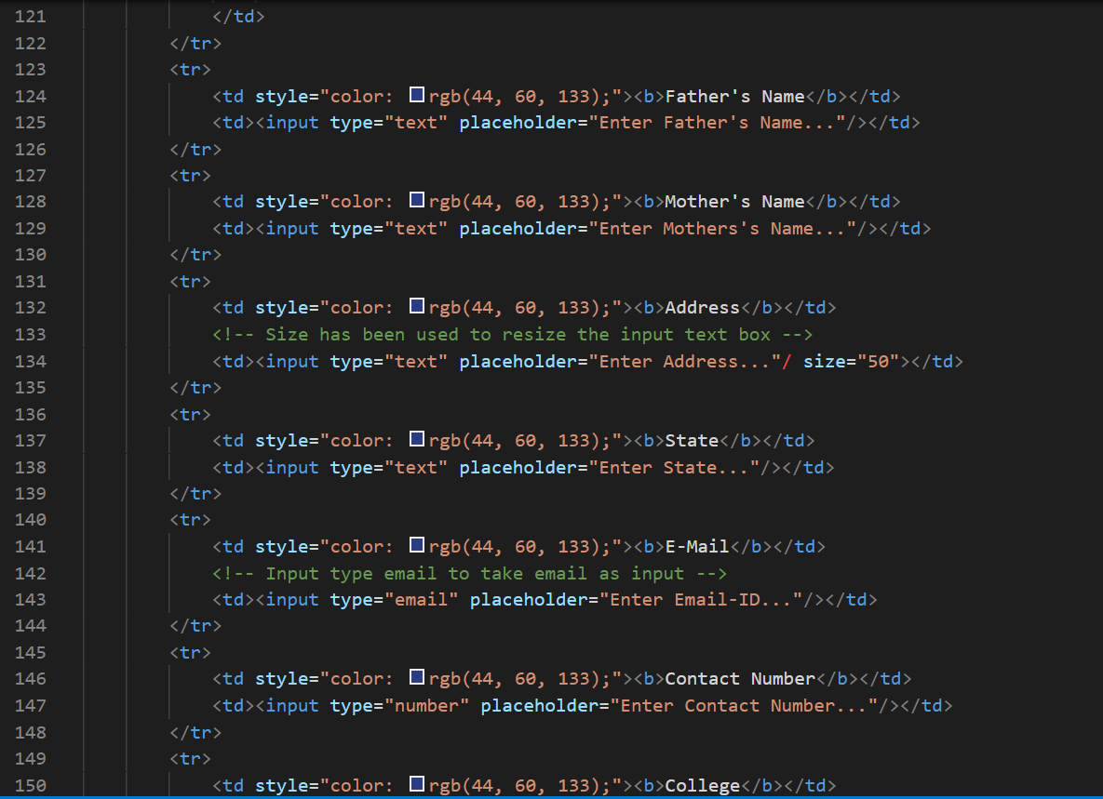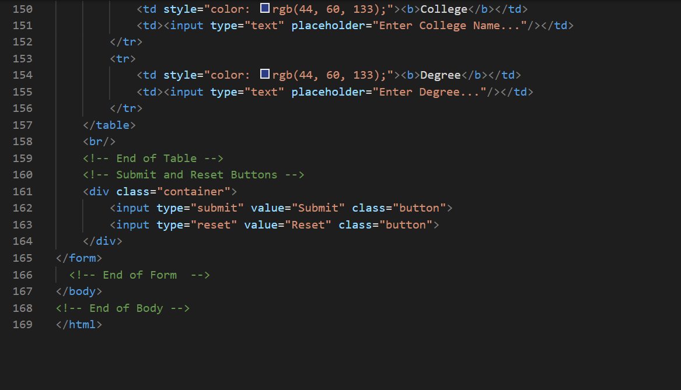 OUTPUT:**  
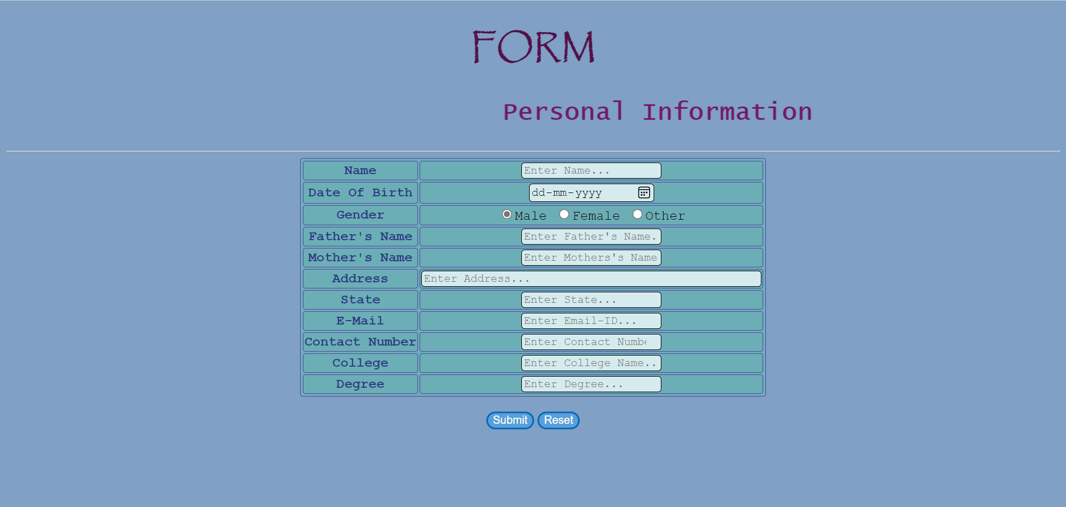

**LAB-3**

## Question: Write a JavaScript code which shows the current date and time. Change the colour of the paragraph element using JavaScript and count the number and names of dropdown menu and show them as pop-up in the window.

**CODE:** 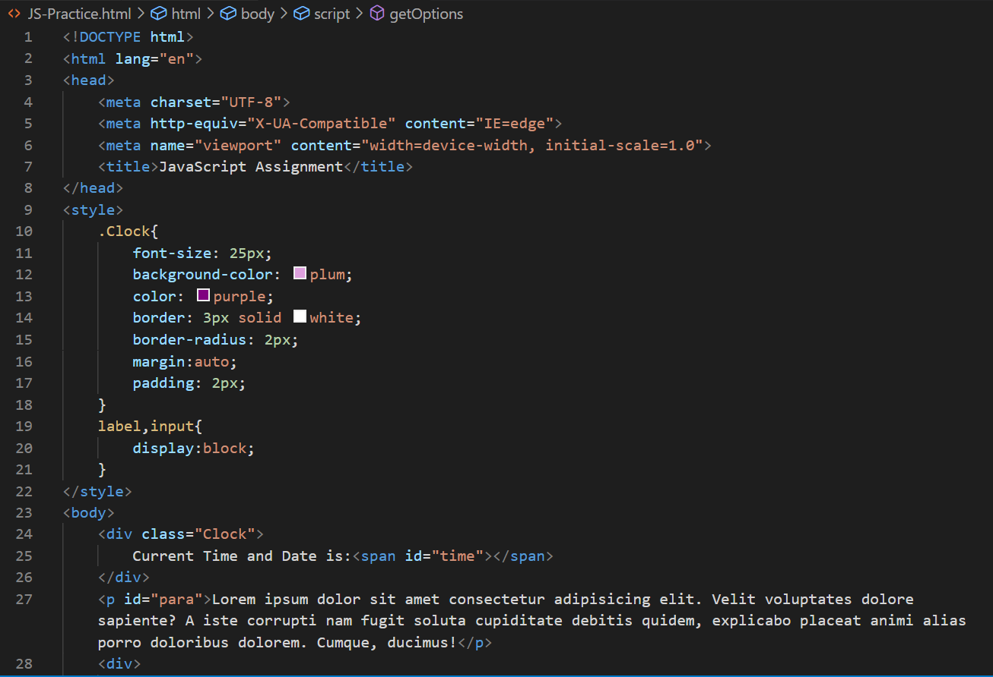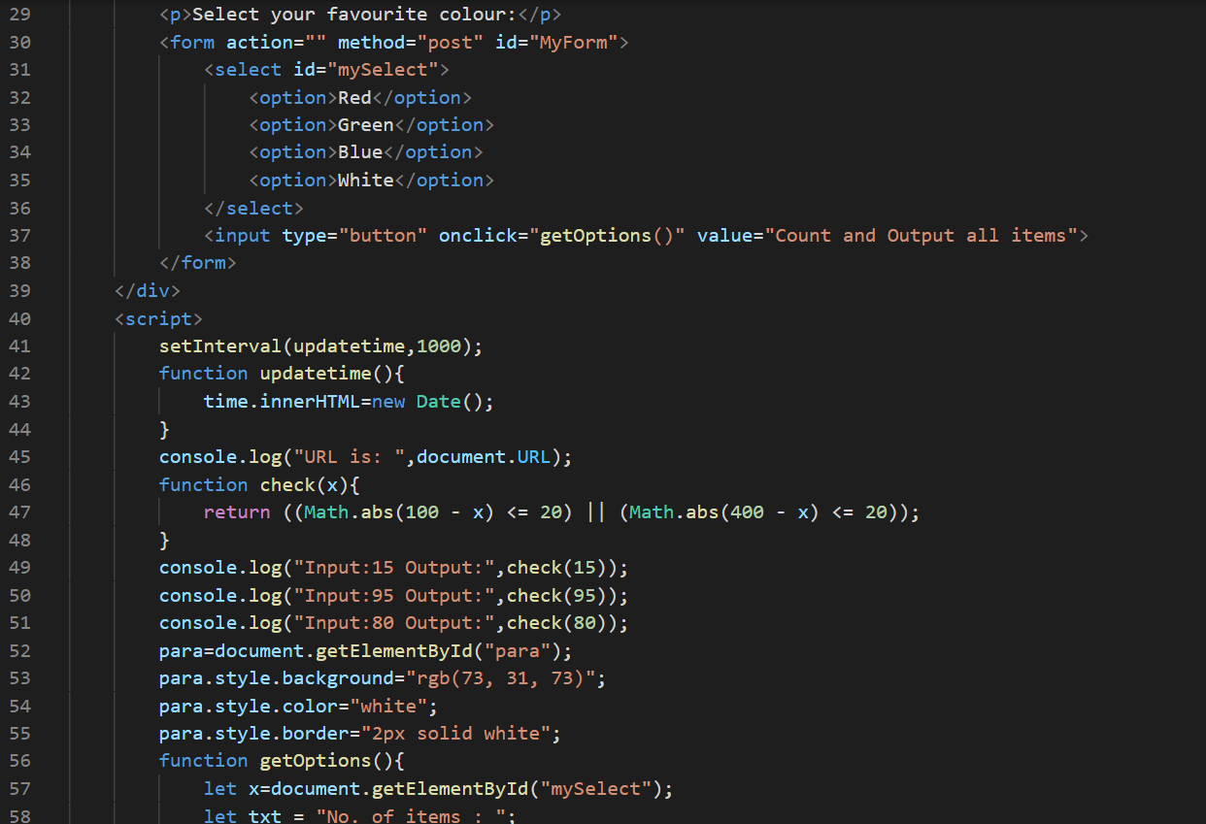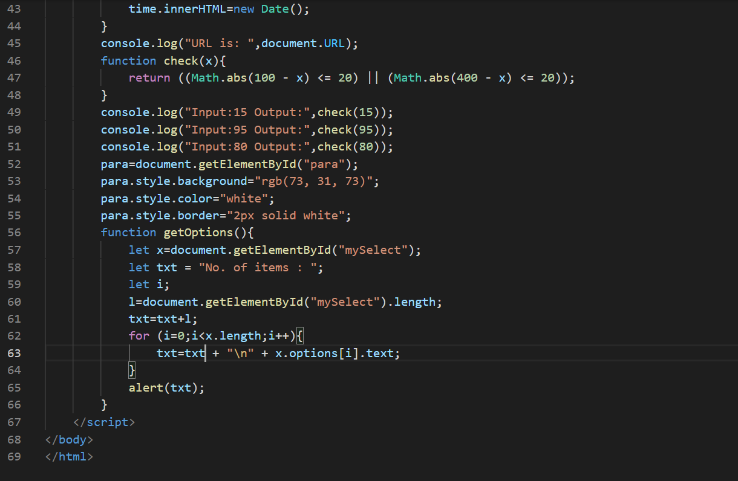

**OUTPUT:** 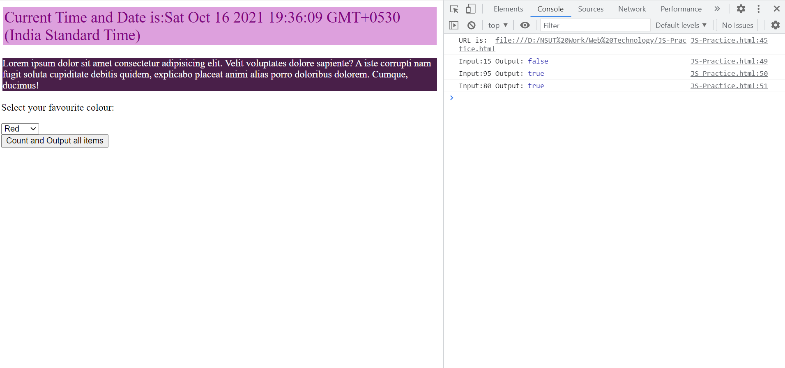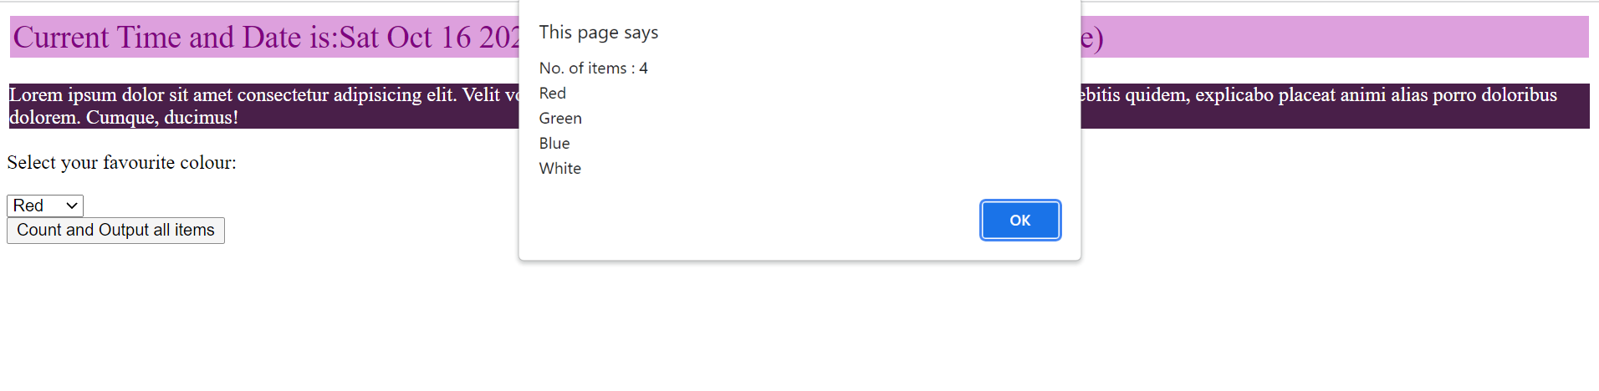

**LAB-4**

## Question: Write a JavaScript to design a simple calculator to perform the following operations: sum, product, difference and quotient.

**CODE:** 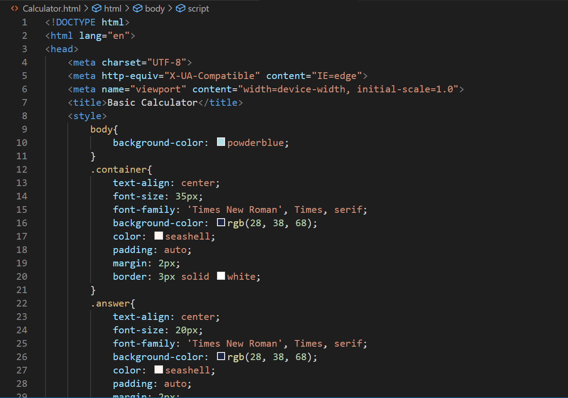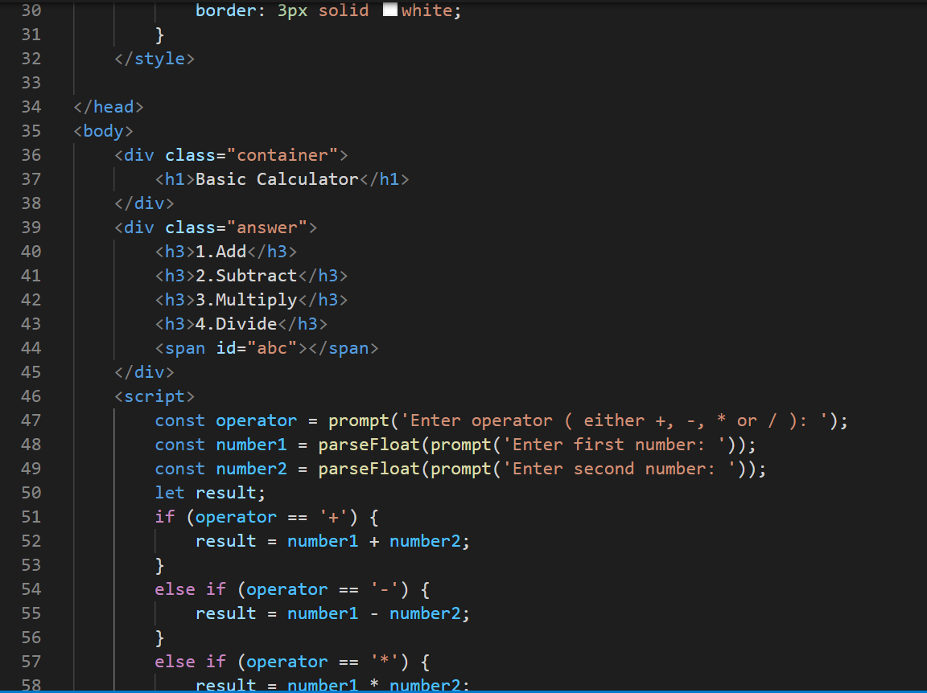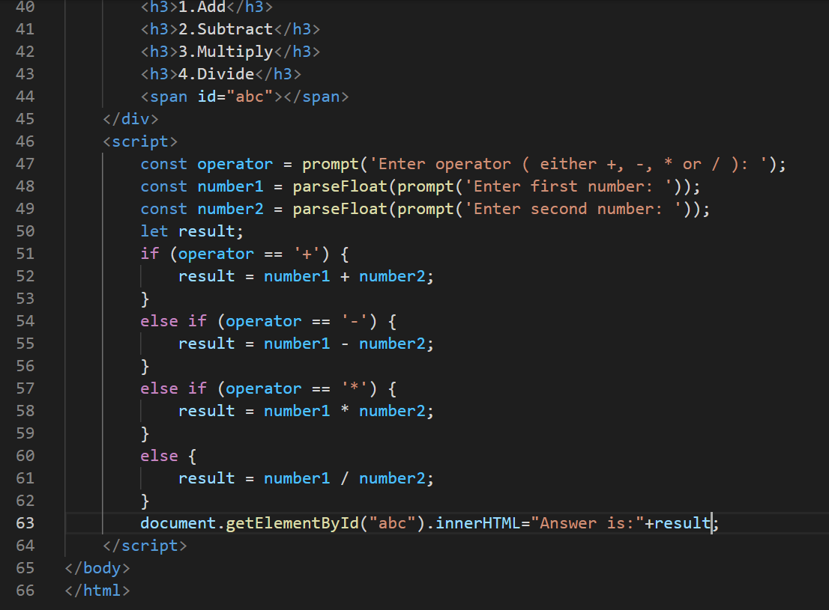

**OUTPUT:**

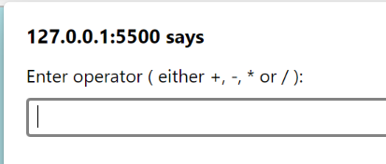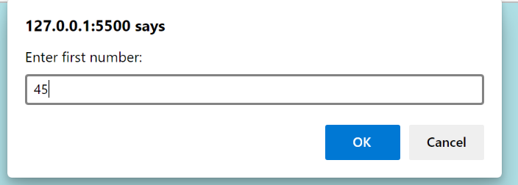  
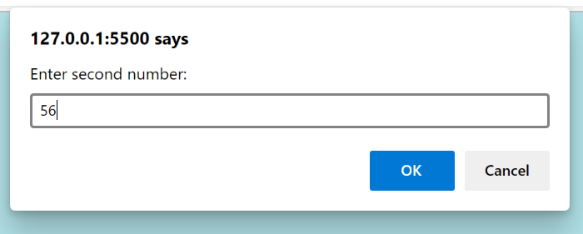

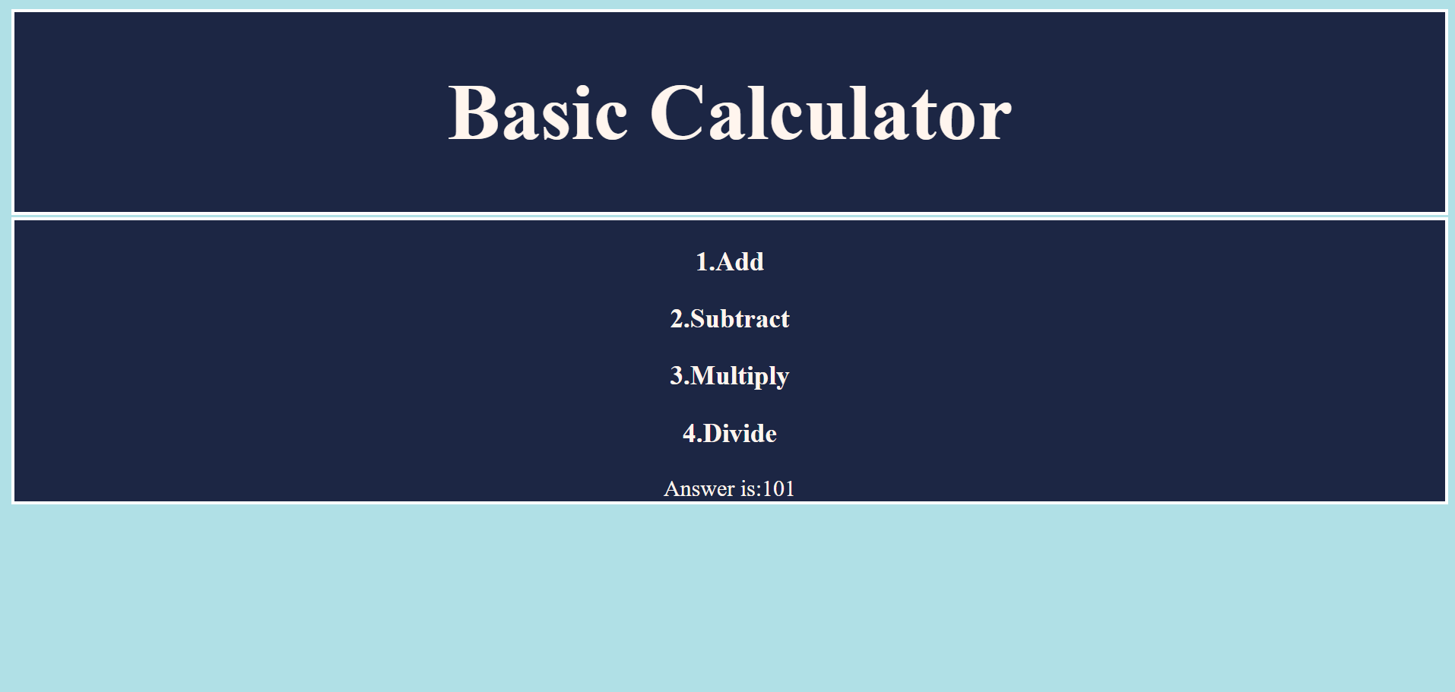

**LAB-5**

## Question: Write a JavaScript that calculates the squares and cubes of the numbers from 0 to 10 and outputs HTML text that displays the resulting values in an HTML table format.

**CODE: 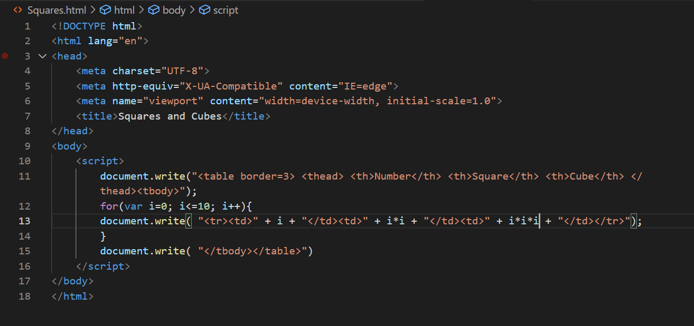 OUTPUT:** 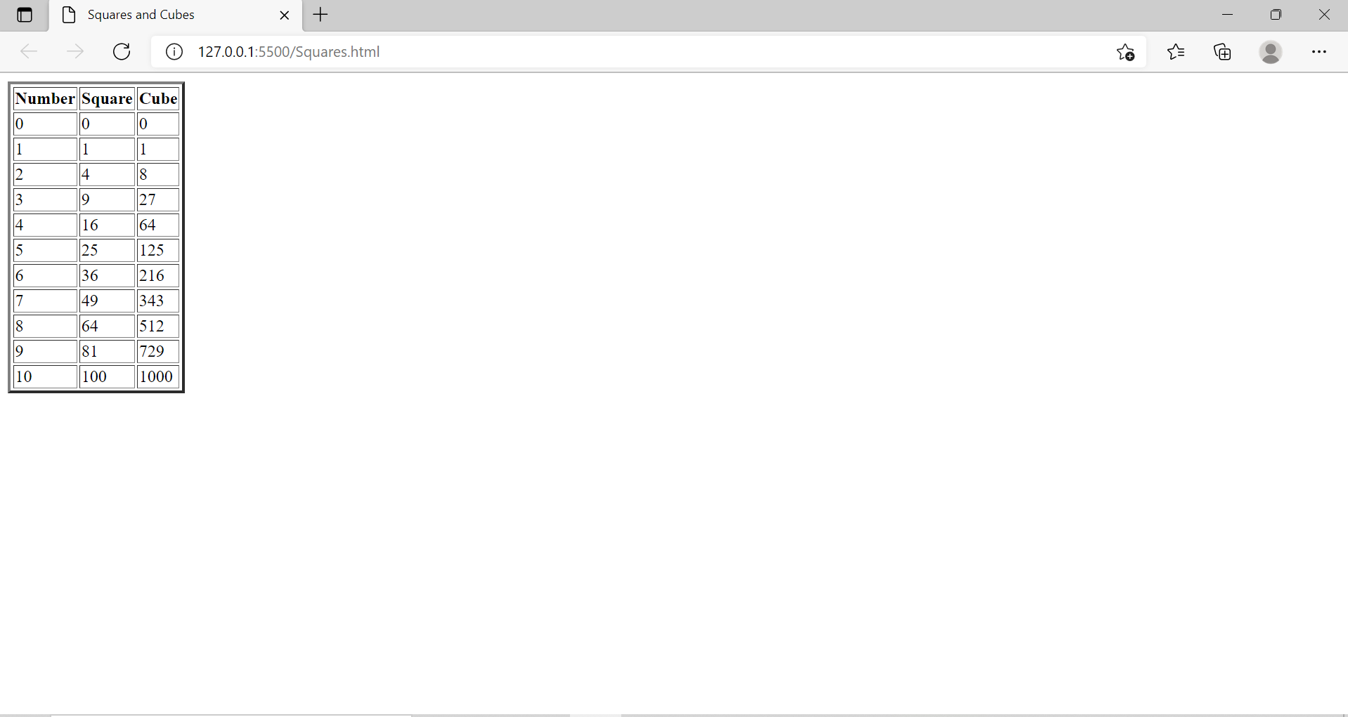

**LAB-6**

## Question: Write a JavaScript code that displays text “TEXT-GROWING” with increasing font size in the interval of 100ms in RED COLOR, when the font size reaches 50pt it displays “TEXT-SHRINKING” in BLUE colour. Then the font size decreases to 5pt.

**CODE: 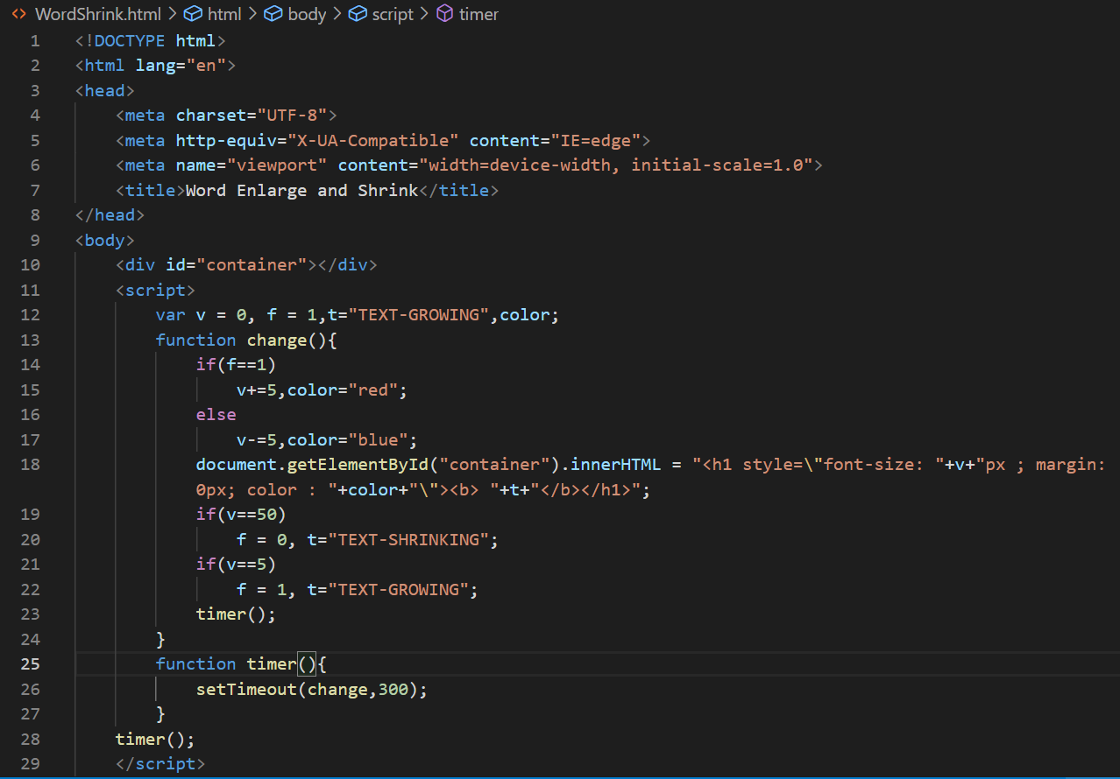 OUTPUT:**

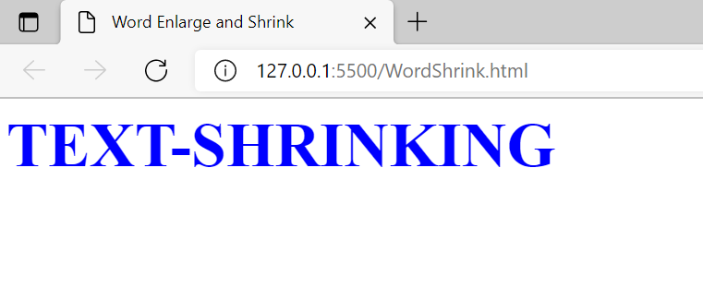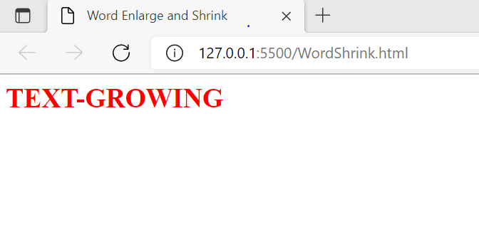

**LAB-7**

## Question: Develop and demonstrate a HTML5 file that includes JavaScript script that uses functions for the following problems:

## a. Parameter: A string

## Output: The position in the string of the left-most vowel

## b. Parameter: A number

## Output: The number with its digits in the reverse order

**CODE: 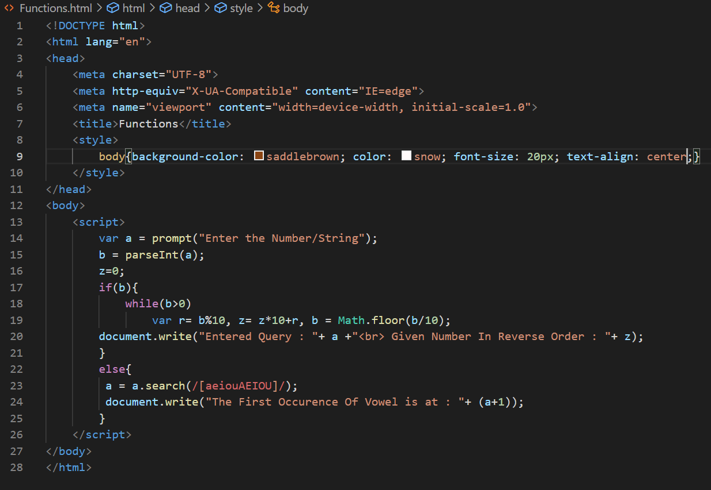 OUTPUT:** 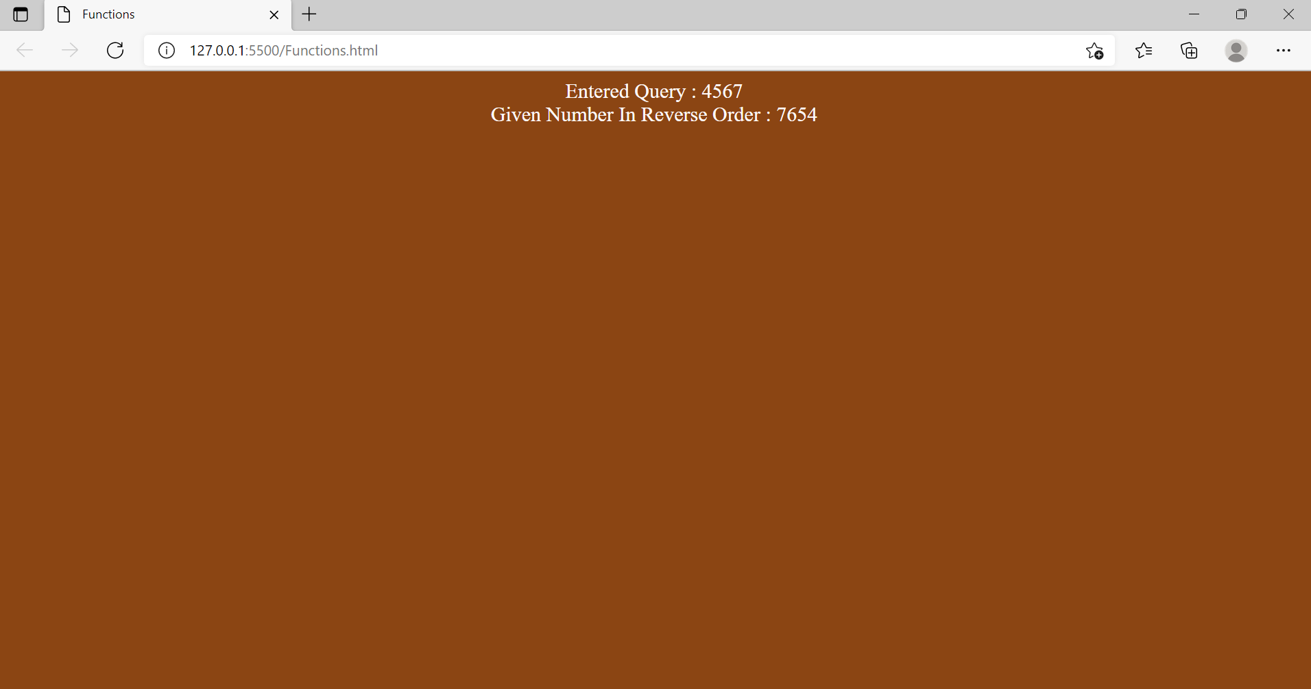

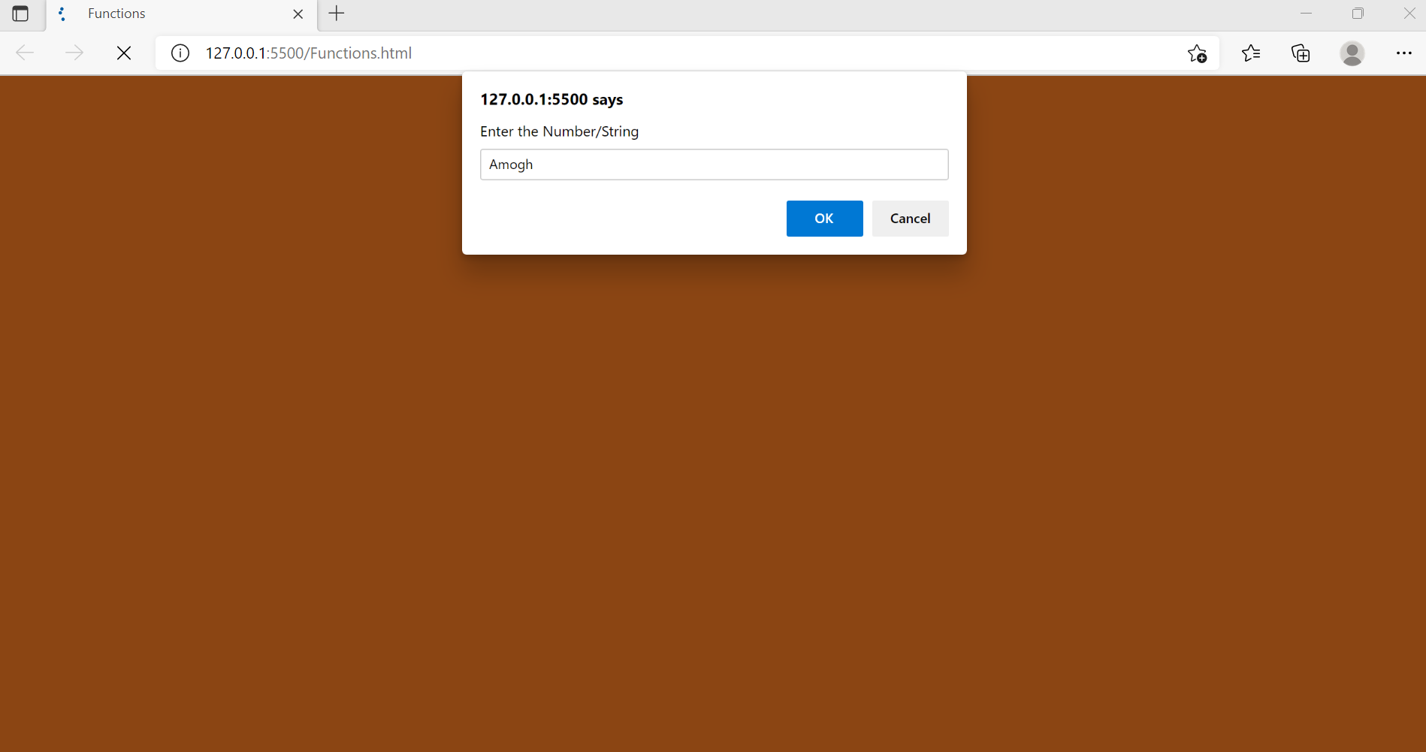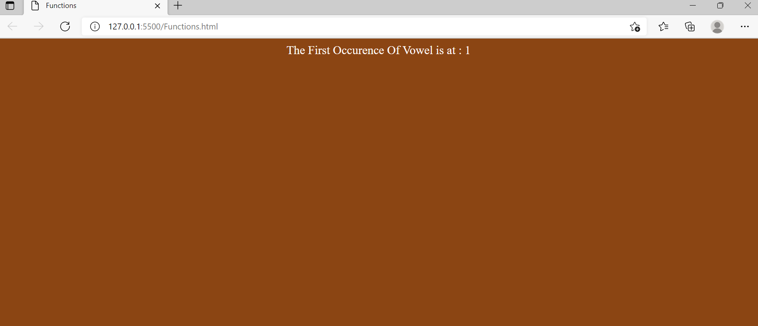

**LAB-8**

## Question: Write an HTML page with JavaScript that takes a number from one text field in the range 0-999 and display it in other text field in words. If the number is out of range, it should show “out of range” and if it is not a number, it should show “not a number” message in the result box.

**CODE: 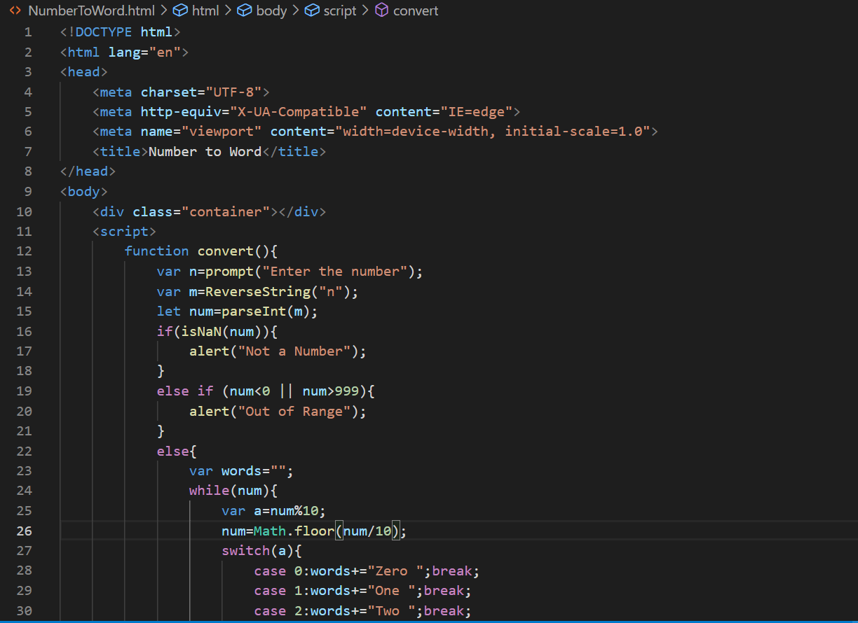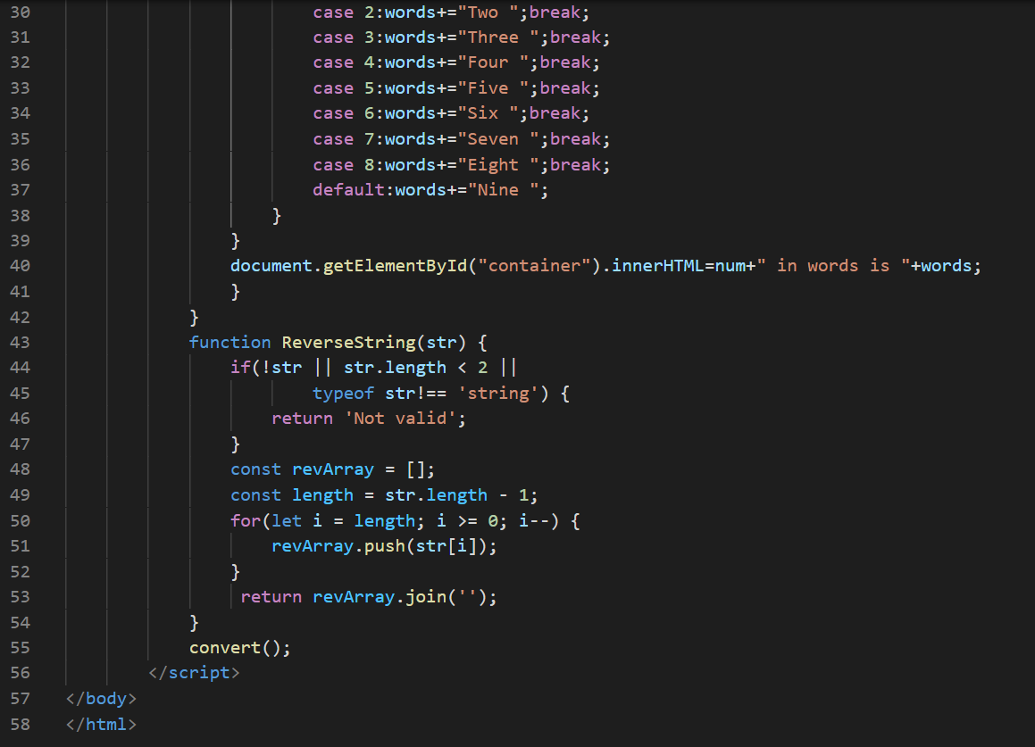 OUTPUT:** 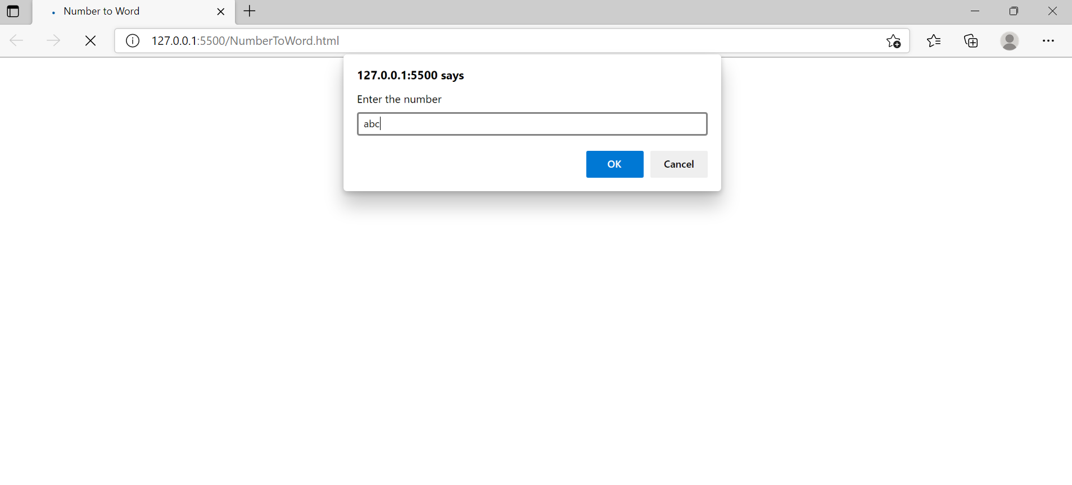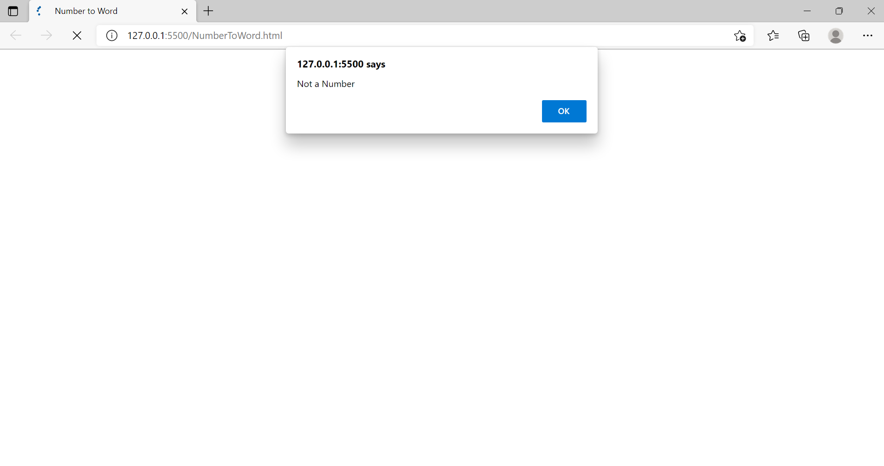

**LAB-9**

**CODE: 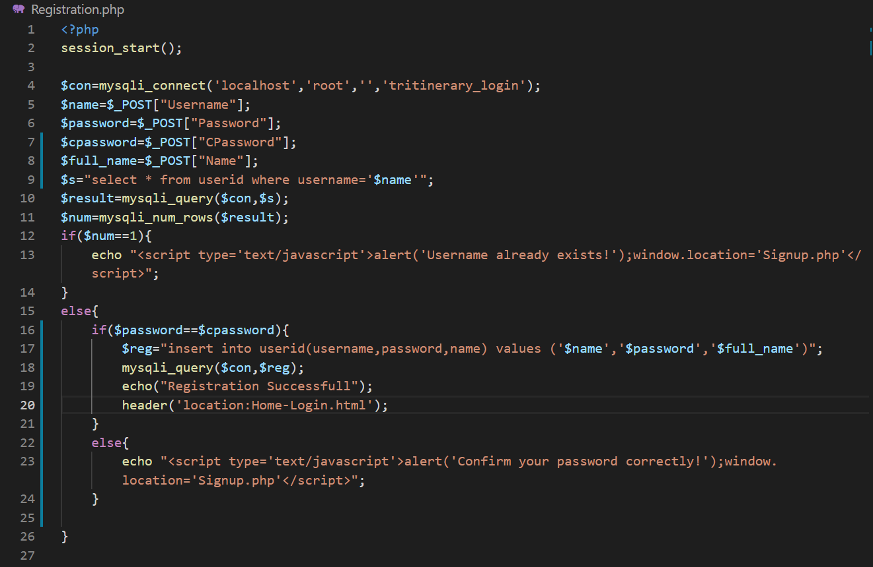 OUTPUT:** 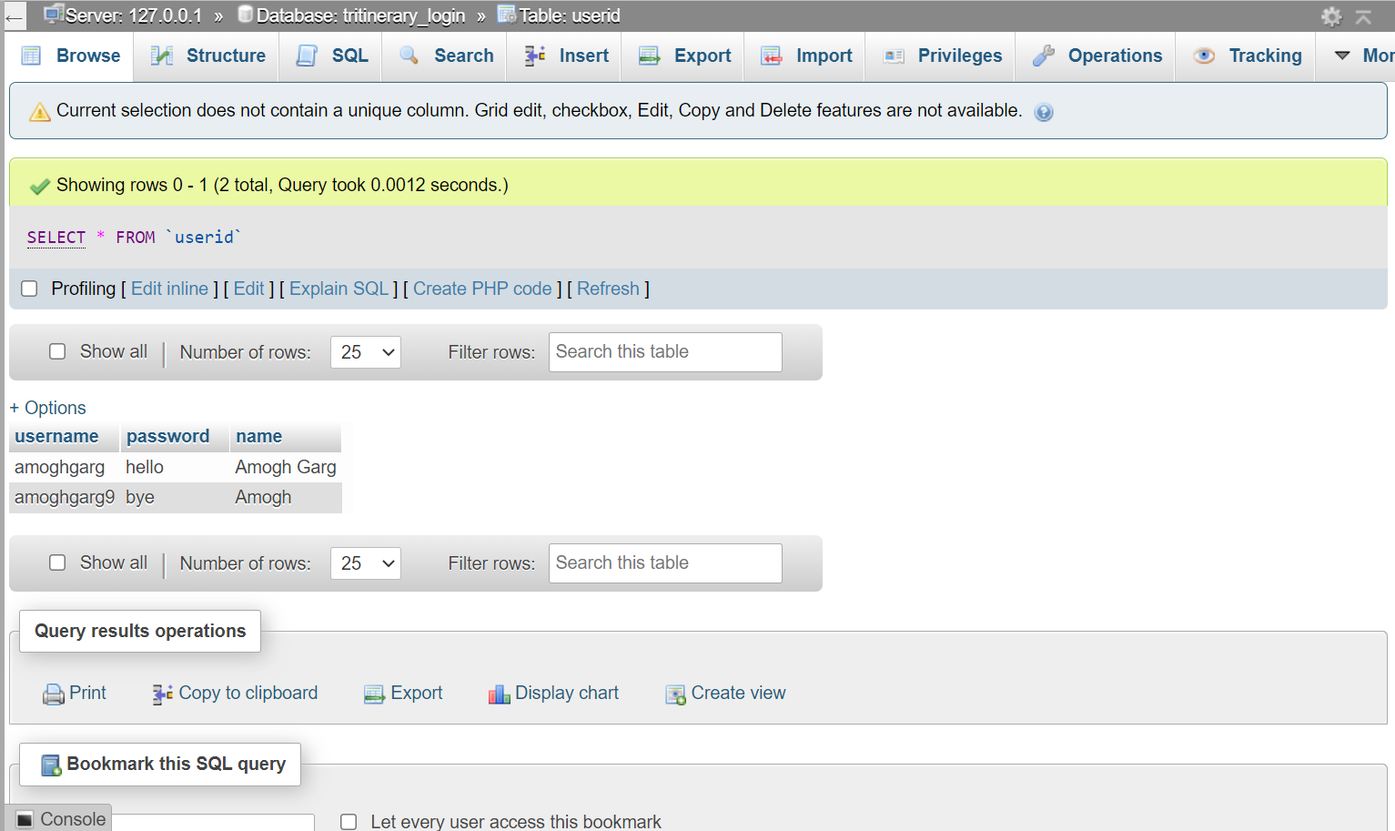

**LAB-10**

**CODE: 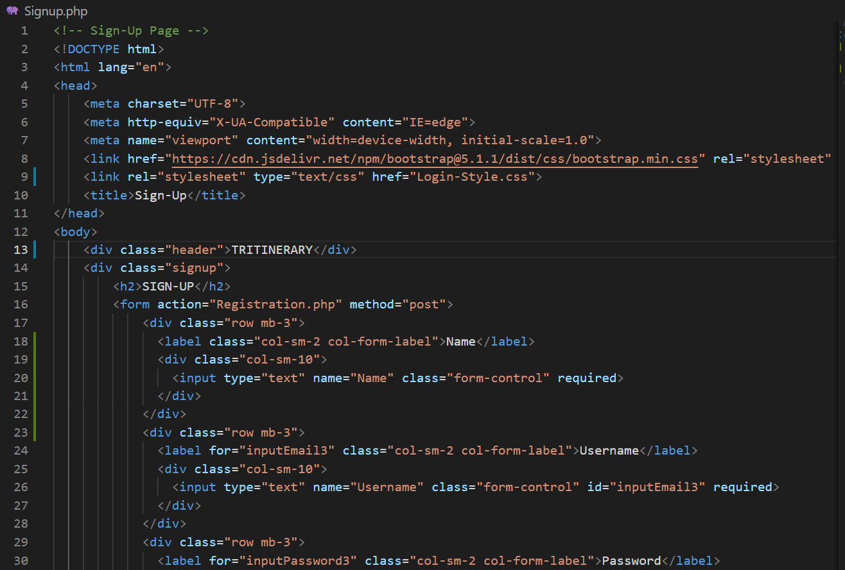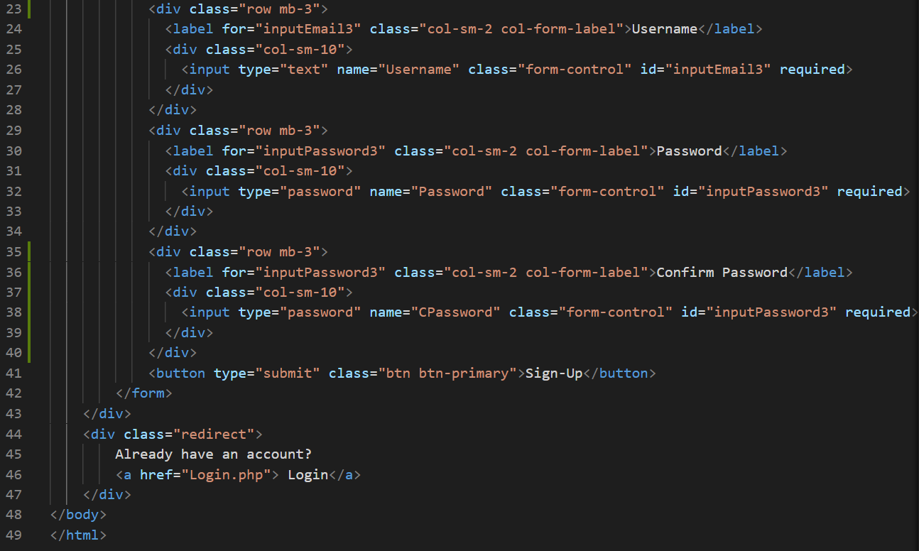 OUTPUT:** 